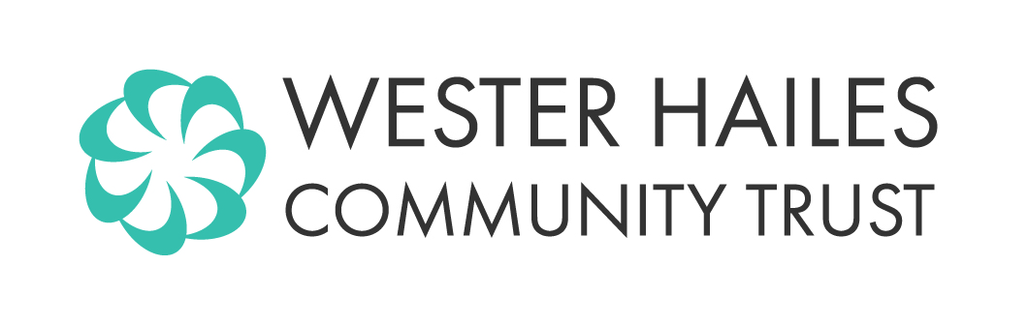
Wester Hailes Community Trust

Membership Application for Associate Membership

Associate Membership is for Unincorporated organisations. A voluntary, not for profit organisation can apply to join Wester Hailes CT if it can show that it an organisation that supports Wester Hailes CT’s purposes and

Is based within Wester Hailes and is of benefit to the people living there.

OR

Operates within Wester Hailes and is of benefit to the people living there.

To be a member, an Associate Member must nominate a named individual to represent them. The individual cannot represent more than one corporate or unincorporated organisation at a time. The named individual must be 16 years or over.

Organisation
Name of Organisation

Address

Tel No |  | Mobile No
Email Address

Website

Named Individual to represent organisation
Name
Address
Tel No |  | Mobile No
Email Address
Date of Birth
Preferred method of contact | Phone / Email / Post
How does your organisation benefit people living in Wester Hailes?
What activities would you like to see the Trust supporting?

An application for associate membership must be signed by an office bearer for the organisation
We agree to abide by the Rules and Policies of Wester Hailes Community Trust

Name |  | Role
Signature |  |  | Date

Completed applications will go to the next Board meeting for approval. If the application is approved the member’s name will be entered on the register of members.

